

**Provisioning Template for Configuration Management**

**User Guide**

|  |  |  |
| --- | --- | --- |
| **Version** | **Remarks** | **Date** |
| **1.0** | **Provisioning Template User Guide for configuration management** | **09/03/2017** |
| **2.0** | **Updated steps to update the mongoDB script.** | **25/04/2017** |
|  |  |  |
|  |  |  |

## Installation of the Template and Helper Script

1. Login to AppViewX.
2. On the left navigation menu, select ***Provisioning***; and click ***Template.***
3. On the upper right portion of the screen click on the  Import button.
4. The following screen will appear. 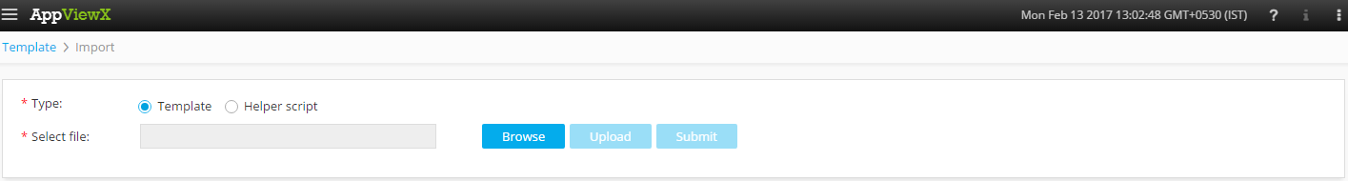
5. Please Select Template/Helper Script.

If Template is chosen,

* 1. Click on *Browse* and select the Zip File of the template which has to be installed/imported and click open.
  2. Click on upload to import the Zip file and display the templates present in the zip file.
  3. Click on submit to deploy the templates into the AppViewX Environment.

If Helper Script is chosen,

1. Click on *Browse* and select the Zip File of the Helper script which has to be installed/imported and click open.
2. Click on upload to import the Zip file and display the Helper Scripts present in the zip file.
3. Click on submit to deploy the Helper Scripts into the AppViewX Environment.
4. Please copy the script "**update_mongodb.py**" into the AppViewX primary DB node under the path "**/home/appviewx/AppViewX/aps/dependencies**".
5. Please copy the file **“config.tar.gz”** into the AppViewX primary DB node under any path and unpack it.
6. Please run the script **“update_mongodb.py”.**
7. Please enter the IP address of the current instance and mongo DB credentials when prompted. Default credentials are admin/admin.
8. Please enter the path of the **“Config folder”** and press enter.

## Configuration Management

1. Login to AppViewX.
2. On the left navigation menu, select ***Provisioning***; and click ***Request***
3. On the upper right portion of the screen, click the  ***Create*** button.
4. Select the provisioning template name from the list – ‘**Gonfiguration_Management_v1**’

**Note:** *If no template is available, this indicates that the user role does not have permission to the requesting template.*

1. Enter the provisioning request description – ‘*Configuration Management*’.
2. Add a default Request scenario name relevant to the template. ***E.g***.: Configuration Management.
3. The list of vendors will be populated in a drop down list, please choose the required vendor.
4. Select the module which is populated in the drop down list based on the selected vendor.
5. Retrieve the list of **Devices** available by clicking on the  button and select the required **Device** on which the configurations have to be pushed.
6. Retrieve the list of Object types available in the selected module by clicking on the  button and select the required **object type.**
7. Select the preferred mode of input for the commands to be pushed.  
   If **TMSH** is selected, then
   1. Please enter the TMSH commands which have to be pushed to the selected device in the **Configuration editor.**

If **CONFIG** is selected, then

1. Select the option to *View or Edit sample* or *View or Edit existing objects.*  
   If *View or Edit sample* is selected, then
   * 1. Retrieve the sample code by clicking on the  button.

If *View or Edit existing objects* is selected, then

1. Retrieve the list of existing objects based on the module selected by clicking on the  button and select the object.
2. Retrieve the configuration of the object by clicking on the  button and the configuration will be populated on the configuration editor.
3. Click on *Submit* to generate work order(s) for the provisioning request.